Govt. High School
Sindhi Jamaat Co-Operative Housing Society, Karachi
PTM (Parents Tacher Meeting)
Strength: 50 | Attended: 23 | Class: Class-3
Time: 9:00 AM to 11:00 AM |  | Date: 16-8-2025

1. Introduction
The Parent-Teacher Meeting (PTM) for Class 3 was conducted to discuss students’ academic performance and overall progress. The session aimed to create a collaborative environment where parents and teachers could exchange feedback regarding students’ learning and development.

2. Objectives
• To update parents about students’ academic progress.
• To highlight areas of strength and improvement for each child.
• To inform Parets about First Assessments
• To strengthen the partnership between parents and teachers for better student growth.

3. Agenda Highlights
The PTM discussion covered the following points:
• Assessment Review: Detailed discussion on students’ performance in assessment papers.
• Progress Update: Highlighting individual strengths and areas where improvement is needed.
• Parental Support: Encouraging parents to provide guidance at home.
• Future Goals: Setting short-term and long-term targets for students’ academic and behavioral development.

4. Review & Feedback
• Parents actively participated and shared their concerns and suggestions.
• Teachers provided constructive feedback on each child’s progress.
• Most parents appreciated the clarity of assessment feedback and assured full cooperation for improvement.

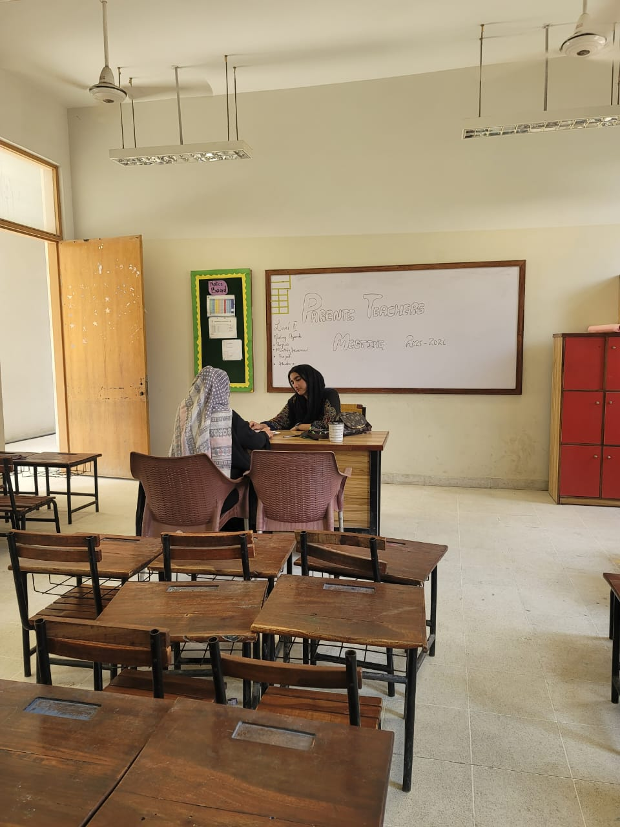
5. Conclusion
The PTM for Class 3 was successfully conducted, ensuring open communication between parents and teachers. The meeting reinforced the importance of collaboration for students’ academic excellence and overall personality development.
